

BANK TRANSACTION ANOMALY DETECTION USING STATISTICAL ANALYSIS

MINI PROJECT REPORT

Submitted by

NASAR ALI J 2117240030093

in partial fulfillment for the award of the degree of
BACHELOR OF ENGINEERING IN
CSE(ARTIFICIAL INTELLIGENCE AND MACHINE LEARNING)

RAJALAKSHMI INSTITUTE OF TECHNOLOGY KUTHAMBAKKAM, CHENNAI - 600 124

ANNA UNIVERSITY: CHENNAI 600 025

JAN/MAY- 2026

ANNA UNIVERSITY: CHENNAI - 600 025

BONAFIDE CERTIFICATE

This is to Certified that this Mini Project report “BANK TRANSACTION ANOMALY DETECTION USING STATISTICAL ANALYSIS” is the Bonafide work of “NASAR ALI J (2117240030093)”, who carried out the project work under my supervision.

SIGNATURE

HEAD OF THE DEPARTMENT
Dr. N. KANAGAVALLI, Ph.D
Assistant Professor,
CSE( AI & ML)
Rajalakshmi Institute of Technology, Chennai – 600 124.
SIGNATURE

SUPERVISOR
Mrs. RUBINA BEGAM
Assistant Professor,
CSE( AI & ML)
Rajalakshmi Institute of Technology, Chennai – 600 124.

Submitted for the Mini Project viva-voce held on ………………..

INTERNAL EXAMINER EXTERNAL EXAMINER

INTRODUCTION

Banking systems today handle millions of transactions every second, making it essential to ensure the security and integrity of financial data. With the rapid growth of digital payments, online banking, and mobile transactions, the risk of fraudulent activities and unusual transaction patterns has significantly increased. Detecting such anomalies is crucial to prevent financial losses and maintain customer trust.

Bank Transaction Anomaly Detection refers to the process of identifying unusual patterns or behaviors in transaction data that deviate from normal activity. These anomalies may indicate fraudulent transactions, system errors, or suspicious activities that require further investigation. Traditional rule-based systems are often insufficient due to the dynamic and complex nature of financial data. Hence, statistical analysis provides an effective and scalable solution for anomaly detection.

Statistical methods analyze transaction data by studying patterns such as transaction amount, frequency, location, and time. By establishing a baseline of normal behavior, these techniques can identify outliers or deviations that may represent anomalies. Common statistical approaches include measures like mean, standard deviation, z-score, and distribution analysis, which help in detecting transactions that significantly differ from typical patterns.

This mini project focuses on applying statistical techniques to detect anomalies in bank transaction datasets. The objective is to identify suspicious transactions efficiently using data analysis and visualization. By implementing this system, it becomes possible to enhance fraud detection mechanisms and support financial institutions in making data-driven decisions.

Overall, this project demonstrates how statistical analysis can be used as a powerful tool to improve security in banking systems by identifying irregularities and preventing potential fraud in a timely manner.

PROBLEM STATE\MENT

In the modern banking system, a large volume of financial transactions is carried out exercise daily. through digital platforms such as online banking, mobile applications, and automated payment systems. With this rapid increase in transaction activity, the likelihood of fraudulent or suspicious transactions has also grown significantly. Identifying such anomalies manually is not feasible due to the massive scale, complexity, and real-time nature of transaction data.
Therefore, there is a need for an efficient and automated system that can analyze transaction data and detect anomalies accurately. This project aims to address this problem by using statistical analysis techniques to identify unusual patterns in bank transactions. By leveraging measures such as mean, standard deviation, and z-score, the system can detect outliers that may indicate fraudulent or suspicious activities, thereby improving the reliability and security of banking operations.
GOAL

The primary goal of this project is to develop a reliable and efficient system for detecting anomalies in bank transaction data using statistical analysis techniques. The project aims to identify unusual or suspicious transaction patterns that deviate from normal behavior, which may indicate potential fraud or system irregularities.

Another important goal is to visualize transaction patterns in a clear and understandable way, making it easier to interpret anomalies and support decision-making.

Overall, the goal is to enhance the security and integrity of banking systems by providing a simple, effective, and data-driven approach to anomaly detection, thereby helping financial institutions take timely action against suspicious activities.

THEORETICAL BACKGROUND

Bank Transaction Analysis:
Bank transaction analysis involves examining financial transaction data to understand customer behavior and detect irregular activities. With the increasing use of digital banking systems, a large amount of transactional data is generated daily. This data includes details such as transaction amount, date, time, and type. Analyzing this data helps in identifying normal patterns and detecting unusual or suspicious transactions that may indicate fraud or errors.

Anomaly Detection:
Anomaly detection is the process of identifying data points that deviate significantly from the normal pattern. In the context of bank transactions, anomalies may represent fraudulent activities, unauthorized access, or system malfunctions. These unusual patterns are often rare and difficult to detect using manual methods. Statistical approaches provide an efficient way to automatically identify such outliers in large datasets.

Statistical Methods:
Statistical analysis plays a key role in detecting anomalies. Important statistical measures used in this project include mean, standard deviation, and z-score. The mean represents the average transaction amount, while standard deviation measures how much the values vary from the average.

Data Visualization:
Data visualization is used to represent transaction data in graphical form, making it easier to identify patterns and anomalies. Common visualization techniques include histograms, box plots, and scatter plots.

Tools and Technologies:
This project is implemented using the Python programming language along with libraries such as Pandas, NumPy, and Matplotlib.

Justification:
This project is justified by the growing need for secure and reliable banking systems. With the rise in digital transactions, detecting fraud and anomalies has become more important than ever. By using statistical analysis, this project provides a simple and effective method to identify suspicious transactions, helping financial institutions improve security and reduce financial risks
ALGORITHM EXPLANATION

Step 1 — Data Collection:

The dataset is collected from online sources containing bank transaction details such as transaction ID, amount, date, type, and account information. This dataset serves as the input for anomaly detection.
#Dataset: bank_transactions.csv

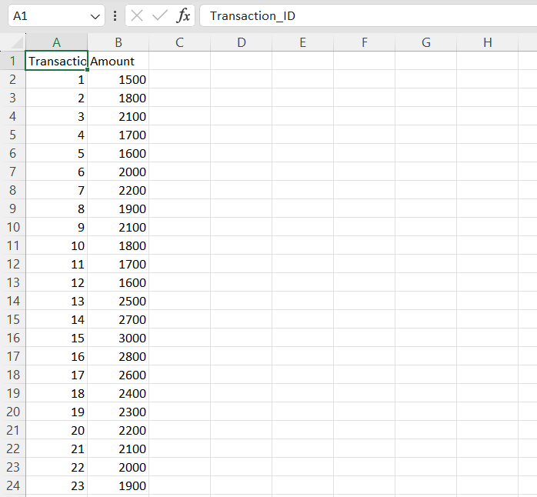

Step 2 — Data Loading:

The dataset is loaded into Python using the Pandas library for further processing and analysis.
(Code: pd.read_csv("bank_transactions.csv") and df.head() output table)

Step 3 — Data Preprocessing:

The dataset is checked for missing or null values and cleaned to ensure accuracy and consistency of data. Unnecessary columns may be removed if required.
(Output of df.isnull().sum() showing no missing values)
Step 4 — Statistical Calculation:
Key statistical measures such as mean and standard deviation of transaction amounts are calculated. These values help in understanding the normal transaction behavior.

Step 5 —Anomaly Detection (Z-Score Method):
The z-score is calculated for each transaction to measure how far it deviates from the mean. Transactions with z-score values greater than a threshold (e.g., 3 or -3) are marked as anomalies.

Step 6 — Data Analysis:
The dataset is analyzed to identify patterns such as frequency of transactions, distribution of amounts, and number of detected anomalies.

Step 7 — Data Visualization:
Graphs such as histograms, box plots, and scatter plots are created to visualize transaction patterns and highlight anomalies.

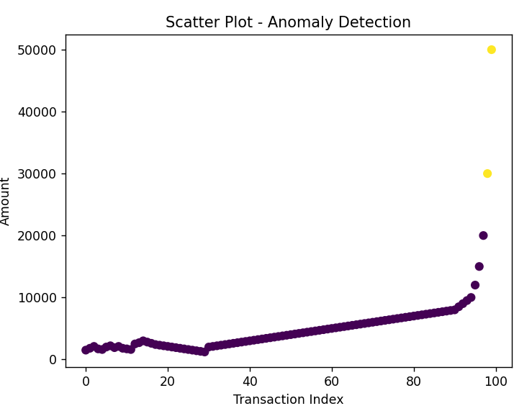

Step 8 — Conclusion:
The analysis helps in identifying unusual transactions effectively using statistical methods, improving fraud detection and ensuring secure banking operations.

IMPLEMENTATION AND CODE

The following python code implements the social media analytics:

import pandas as pd
import numpy as np
import matplotlib.pyplot as plt

# LOAD DATASET
df = pd.read_csv("transactions.csv")

print("\n===== FIRST 5 RECORDS =====\n")
print(df.head())

# DATA CHECK
print("\n===== DATA INFO =====\n")
print(df.info())

print("\n===== MISSING VALUES =====\n")
print(df.isnull().sum())

# BASIC STATISTICS
mean = df["Amount"].mean()
std = df["Amount"].std()

print("\n===== STATISTICS =====")
print("Mean:", mean)
print("Standard Deviation:", std)

# Z-SCORE CALCULATION
df["Z_score"] = (df["Amount"] - mean) / std

#ANOMALY DETECTION
threshold = 3

df["Anomaly"] = df["Z_score"].apply(
lambda x: "Yes" if abs(x) > threshold else "No"
)

# PRINT ANOMALIES
anomalies = df[df["Anomaly"] == "Yes"]

print("\n🚨 ===== ANOMALIES DETECTED ===== 🚨\n")
print(anomalies)

print("\nTotal Anomalies Found:", len(anomalies))

# SAVE OUTPUT
df.to_csv("output.csv", index=False)
print("\nOutput file saved as 'output.csv'")

# ---------------- VISUALIZATION ----------------

# 1. SCATTER PLOT (Anomalies Highlighted)
plt.figure()
colors = df["Anomaly"].map({"Yes": 1, "No": 0})

plt.scatter(df.index, df["Amount"], c=colors)
plt.title("Scatter Plot - Anomaly Detection")
plt.xlabel("Transaction Index")
plt.ylabel("Amount")
plt.grid()
plt.show()

# 2. HISTOGRAM (Distribution)
plt.figure()
plt.hist(df["Amount"], bins=20)
plt.title("Histogram - Transaction Distribution")
plt.xlabel("Amount")
plt.ylabel("Frequency")
plt.grid()
plt.show()

# 3. BOX PLOT (Outliers Detection)
plt.figure()
plt.boxplot(df["Amount"])
plt.title("Box Plot - Detecting Outliers")
plt.ylabel("Amount")
plt.grid()
plt.show()

# 4. LINE PLOT (Trend)
plt.figure()
plt.plot(df["Amount"])
plt.title("Line Plot - Transaction Trend")
plt.xlabel("Transaction Index")
plt.ylabel("Amount")
plt.grid()
plt.show()

OUTPUT:

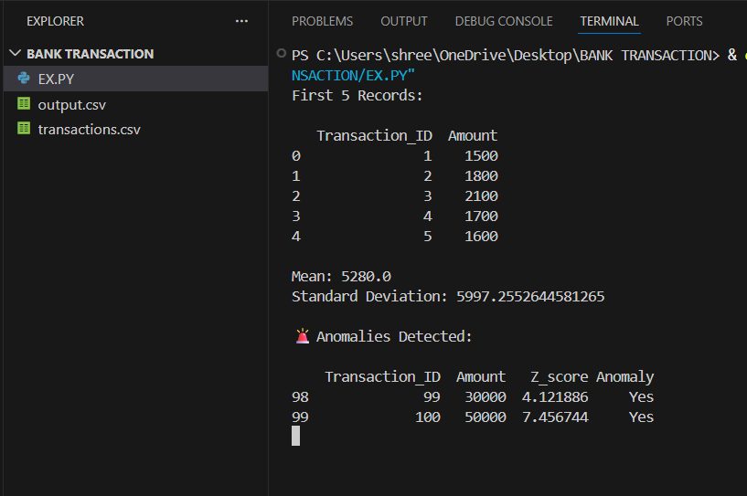

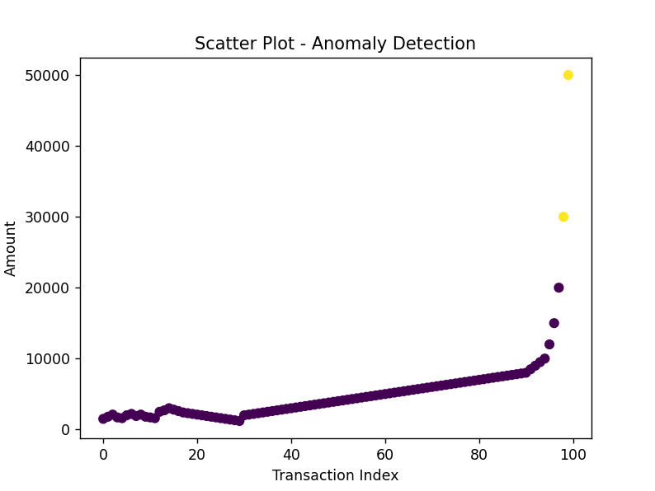

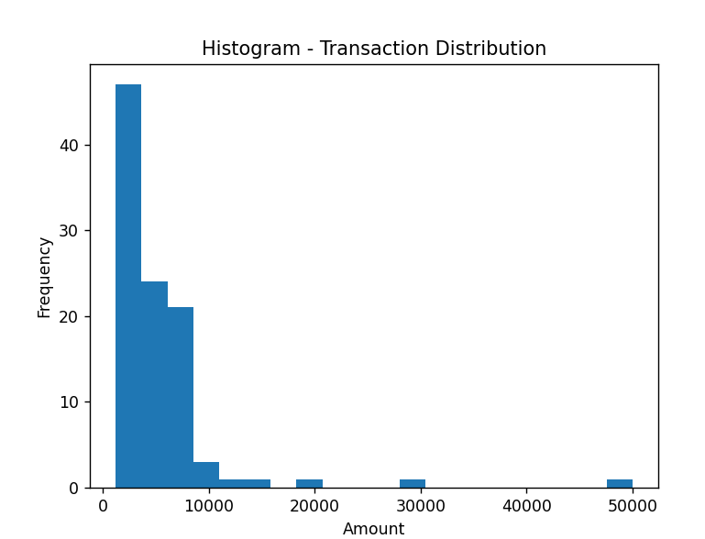

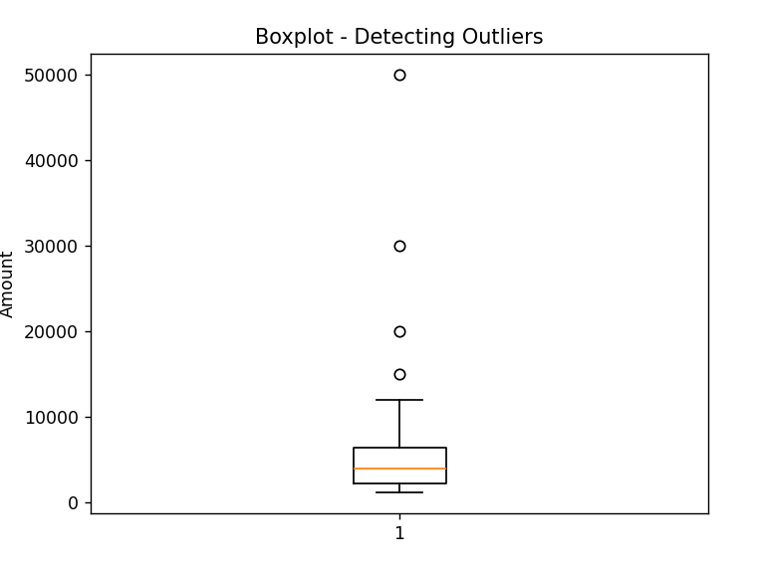

RESULTS AND FUTURE ENHANCEMENT

Results:
The developed system successfully analyzes bank transaction data and identifies unusual patterns using statistical techniques. By applying measures such as mean, standard deviation, and z-score, the system effectively detects anomalies in transaction amounts.
The results show that most transactions follow a normal pattern, while a small number of transactions significantly deviate from the average. These deviations are identified as anomalies, which may indicate fraudulent or suspicious activities. The system accurately flags such transactions, making it easier for further investigation.

Overall, the project successfully demonstrates how statistical analysis can be used to convert raw transaction data into meaningful insights, improving the detection of anomalies and enhancing the security of banking systems.
Comparison with Other Approaches:

Traditional methods of analyzing social media data often involve manual observation or simple metrics, which may not provide detailed insights. In contrast, this project uses data analytics techniques to process large datasets efficiently and generate meaningful results.
Unlike basic analysis methods, this approach combines multiple engagement metrics and visualizes the data, making it easier to interpret patterns and trends. It provides a more structured and data-driven way of understanding user interaction compared to manual methods.

Future Enhancements:

- Use of Larger Datasets:
The project can be improved by using larger and real-world banking datasets to increase accuracy and reliability of anomaly detection.

- Integration of Machine Learning:
Advanced machine learning algorithms such as Isolation Forest or Neural Networks can be implemented to improve detection accuracy and reduce false positives.

- Real-Time Transaction Monitoring:
The system can be enhanced to detect anomalies in real-time, allowing immediate action against suspicious transactions.

- Interactive Dashboard:
A user-friendly dashboard can be developed using tools like Power BI or Tableau to visualize transaction data and anomalies interactively.

- Multi-Feature Analysis:
Future improvements can include additional features such as transaction location, time, and user behavior to provide deeper insights and more accurate anomaly detection.

Git Hub Link for the project and report

Git Hub link of the project
and report

REFERENCES:

- Python Software Foundation. Python Documentation.
Available at: https://docs.python.org/
- McKinney, W. (2010). Data Structures for Statistical Computing in Python.
Proceedings of the 9th Python in Science Conference.
- Pandas Documentation. Python Data Analysis Library.
Available at: https://pandas.pydata.org/docs/
- Matplotlib Development Team. Matplotlib Documentation.
Available at: https://matplotlib.org/stable/contents.html
- Kaggle. Bank Transaction / Fraud Detection Datasets.
Available at: https://www.kaggle.com/’
- IBM Cloud Education. What is Data Analytics?
Available at: https://www.ibm.com/topics/data-analytics
- Han, J., Kamber, M., & Pei, J. (2011). Data Mining: Concepts and Techniques.
Morgan Kaufmann Publishers.

